Week 3 tutorial - Users and Permission in Linux
This lab explores Linux user accounts and file permissions, which control access to system resources. Each file has an owner, group, and permission set consisting of read, write, and execute rights. Commands such as adduser, passwd, chmod, and deluser allow administrators to manage user accounts and file permissions.
Screenshots included
1️⃣ cat /etc/passwd
2️⃣ sudo adduser john
3️⃣ cat /etc/passwd showing john
4️⃣ sudo passwd john
5️⃣ sudo deluser john
6️⃣ cat /etc/passwd after deletion
7️⃣ ls -l
8️⃣ chmod u-r Videos
9️⃣ ls -l again
Step 1 — Check Existing Users
Purpose: Displays all system users.
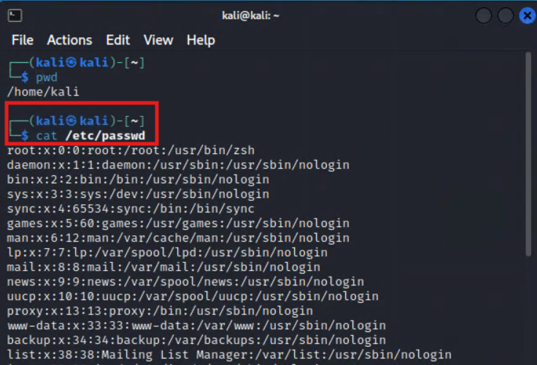
Figure 1 Check encryption tools installed
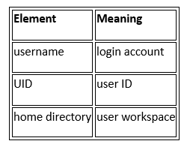
Observation
- root → administrator
- kali → normal user
- others → system service accounts

Step 2 — Create New User
Command: sudo adduser john
Password example: john
Press Enter for optional fields.
What happens internally:
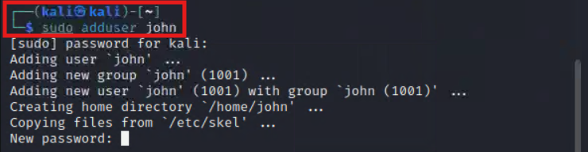
Figure 1 Check encryption tools installed
Linux creates:
- /home/john
- and adds the user to /etc/passwd.
The tutorial demonstrates creating a user account using the adduser command.
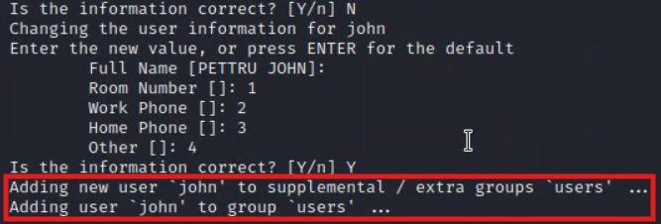
Figure 1 Check encryption tools installed
Step 3 — Verify User Creation
Command: cat /etc/passwd
Look for: john:x:1001:1001
Explanation: User IDs typically start from 1000 for normal users.
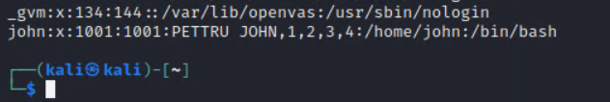
Figure 1 Check encryption tools installed
Step 4 — Change User Password
Command: sudo passwd john
Example output: password updated successfully
Purpose: Allows administrator to reset passwords.
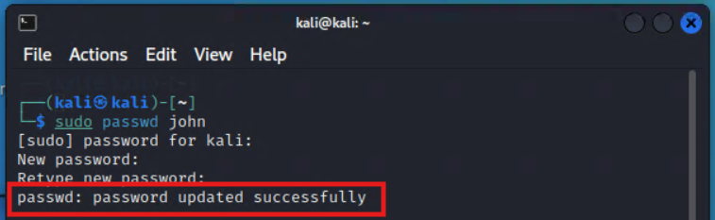
Figure 1 Check encryption tools installed
Step 5 — Delete User
Command: sudo deluser --remove-home john
Explanation:
- Removes user account
- Removes home directory
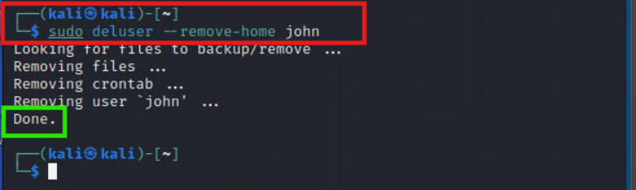
Figure 1 Check encryption tools installed
Step 6 — Verify User Deletion
Command: cat /etc/passwd
Ensure john no longer appears.
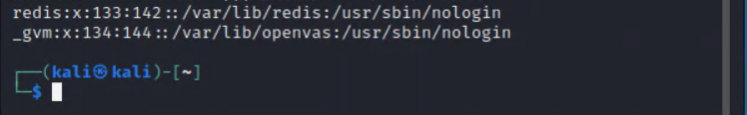
Figure 1 Check encryption tools installed
Step 7 — Check File Permissions
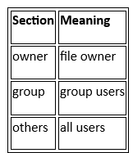
Command: ls -l
Example output : drwxr-xr-x 2 kali kali Desktop-rw-r--r-- 1 kali kali file.txt
Permissions format: rwx r-x r-x
Linux permissions determine who can access system resource
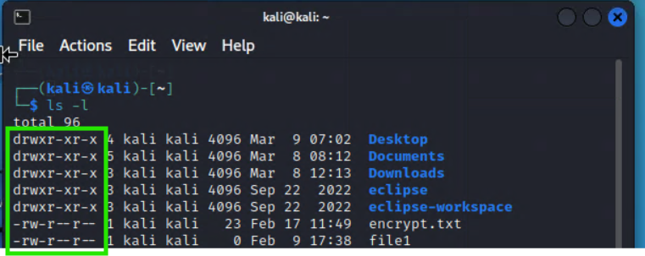
Figure 1 Check encryption tools installed
Step 8 — Modify Permissions (Symbolic)
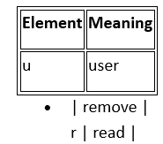
Command: chmod u-r Videos
Meaning
After change: (ls -l) You will see read permission removed, see below screen shots.

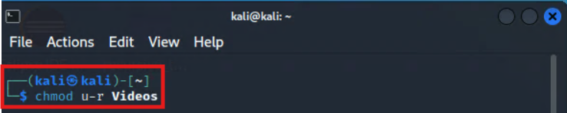
Figure 1 Check encryption tools installed
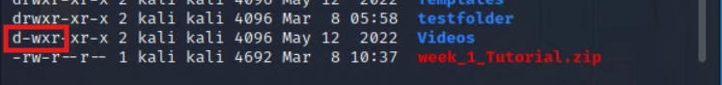
Figure 1 Check encryption tools installed

Step 9 — Numeric Permissions (Research Exercise)
permissions in Linux can be Read, Write and Execute on Users (u), Groups (g) and Others (o)
Here are the initial permissions for file1.txt: rwx r-x r-x (see screenshot)
rwx for Users (u), r-x for Groups (g) and r-x for Others (o)
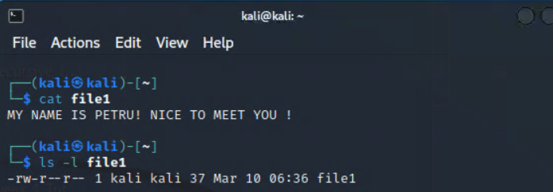
Figure 1 Check encryption tools installed
Example: chmod 755 file1.txt
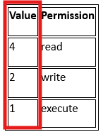
Numeric system
Example:
7 = rwx
5 = r-x
Meaning chmod 755 file.txt will set permission to rwx r-x r-x
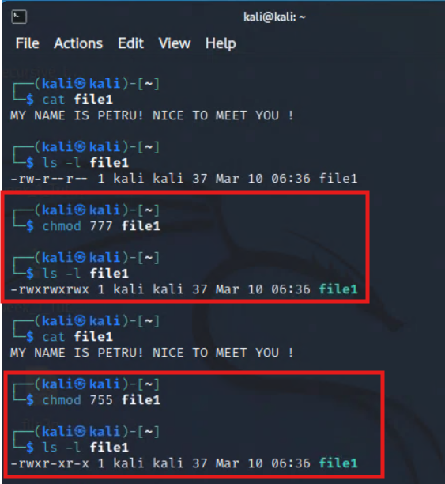
These screenshots show user management and permission modification

